# Cloud Computing Architecture

As we know, cloud computing technology is used by both small and large organizations to **store the information** in cloud and **access** it from anywhere at anytime using the internet connection.

Cloud computing architecture is a combination of **service-oriented architecture** and **event-driven architecture**.

Cloud computing architecture is divided into the following two parts -

* Front End
* Back End

The below diagram shows the architecture of cloud computing -

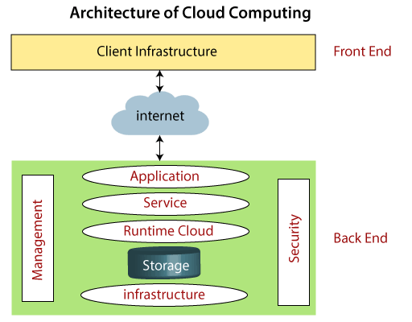

### Cloud Computing for Beginners

### Front End

The front end is used by the client. It contains client-side interfaces and applications that are required to access the cloud computing platforms. The front end includes web browsers (including Chrome, Firefox, internet explorer, etc.), thin & fat clients, tablets, and mobile devices.

### Back End

The back end is used by the service provider. It manages all the resources that are required to provide cloud computing services. It includes a huge amount of data storage, security mechanism, virtual machines, deploying models, servers, traffic control mechanisms, etc.

#### Note: Both front end and back end are connected to others through a network, generally using the internet connection.

## Components of Cloud Computing Architecture

There are the following components of cloud computing architecture -

**1. Client Infrastructure**

Client Infrastructure is a Front end component. It provides GUI (Graphical User Interface)  to interact with the cloud.

**2. Application**

The application may be any software or platform that a client wants to access.

**3. Service**

A Cloud Services manages that which type of service you access according to the client’s requirement.

Cloud computing offers the following three type of services:

**i. Software as a Service (SaaS) –**It is also known as **cloud application services**. Mostly, SaaS applications run directly through the web browser means we do not require to download and install these applications. Some important example of SaaS is given below –

**Example:** Google Apps, Salesforce Dropbox, Slack, Hubspot, Cisco WebEx.

**ii. Platform as a Service (PaaS) –** It is also known as **cloud platform** **services**. It is quite similar to SaaS, but the difference is that PaaS provides a platform for software creation, but using SaaS, we can access software over the internet without the need of any platform.

**Example:** Windows Azure, Force.com, Magento Commerce Cloud, OpenShift.

**iii. Infrastructure as a Service (IaaS) –**It is also known as **cloud infrastructure services**. It is responsible for managing applications data, middleware, and runtime environments.

**Example:** Amazon Web Services (AWS) EC2, Google Compute Engine (GCE), Cisco Metapod.

**4. Runtime Cloud**

Runtime Cloud provides the **execution and runtime environment** to the virtual machines.

**5. Storage**

Storage is one of the most important components of cloud computing. It provides a huge amount of storage capacity in the cloud to store and manage data.

**6. Infrastructure**

It provides services on the **host level**, **application level**, and **network level**. Cloud infrastructure includes hardware and software components such as servers, storage, network devices, virtualization software, and other storage resources that are needed to support the cloud computing model.

**7. Management**

Management is used to manage components such as application, service, runtime cloud, storage, infrastructure, and other security issues in the backend and establish coordination between them.

**8. Security**

Security is an in-built back end component of cloud computing. It implements a security mechanism in the back end.

**9. Internet/Network**

The Internet is medium through which front end and back end can interact and communicate with each other.